St. Alphonsus - Soccer Team - Fundraiser!

Normal Price for Frozen Pizza @ Lou’s is $15-$18

St. Alphonsus’s Special Coupon Price is $13.00

Get them while you can! Orders due Oct. 6!

Please fill out the order form with your contact information so that the coupons may be distributed to you within 1-2 weeks after the fundraiser ends. Spread the word to Family & Friends!

FROZEN PIZZA VOUCHERS = $13.00 each

(Send cash or check with your order form to St. Alphonsus Athletics)
- Each voucher is good for one 9” frozen Deep Dish pizza (cheese, sausage, pepperoni, or spinach ONLY) to be picked up by customers at any Lou Malnati’s location, including Arizona and Indiana, and Wisconsin. Coupon good for 6 months, the expiration date will be at the bottom of the coupon. At this time, a gluten free option is not available with the vouchers.
- Vouchers may be used for a frozen “heart shaped” pizza during holiday season upon availability and depending what is in stock at that location.
- THESE ARE NOT VALID FOR SHIPPING FROZEN DEEP DISH PIZZAS. Coupons must be brought in the store to be picked up.
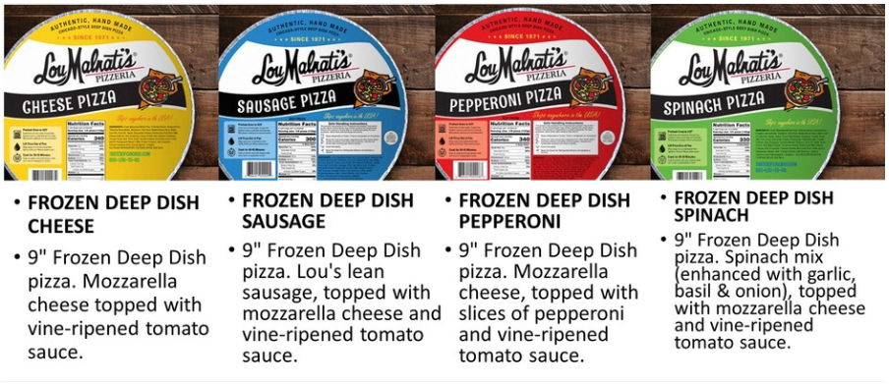
- Vouchers cannot be used towards other food items or towards shipping.

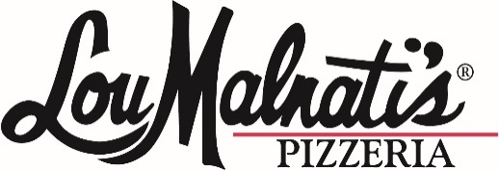

Frozen Pizza Coupon Fundraiser Order Form!
Cost: $13.00 each
Proceeds benefit ___St. Alphonsus Athletics____
Pizza coupons may be redeemed at any area Lou Malnati’s location for one 9” FROZEN pizza (sausage, pepperoni, cheese, or spinach). Offer subject to restaurant availability. Coupon has no cash value and may not be used toward the purchase of any other items. Coupons will be delivered to customer at a later date. Each coupon is valid for 6 months from the date the order is placed.
Name | Phone Number/Address | # of coupons ordered | Cost | Paid Y/N (Cash or Check)

